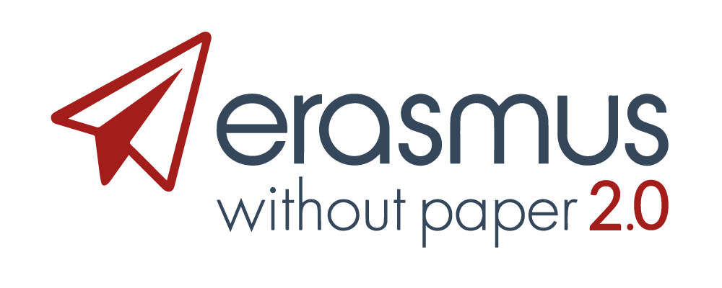
EWP Collaboration Agreement
Terms of use of the EWP Network

Parties in this agreement
The following parties: EWP Project Consortium, which combines the legal entities participating as Beneficiaries of the project “Erasmus Without Paper 2.0”, having signed Grant Agreement No 2017-3429/001-011 with the EU Commission and having signed a separate mandate to be represented here by the coordinating institution European University Foundation,16C rue de Canach, 5353 Oetrange, Luxembourg and more specifically by Joao Bacelar, its Executive Manager, referred to hereinafter as the EWP Consortium;
and the higher Education institution (Name of the HEI)
having its main office at (…. address), PIC number: xxxx (or Erasmus code), duly represented by (name + position);
referred to hereinafter as Institution,
have agreed the following:
Both parties have agreed to this Collaboration Agreement determining the terms of use of the EWP electronic network and associated APIs (from now on, “this Agreement”), in order to set the following conditions to receive a license to link external software to the EWP Network and use the name and logo of EWP in its documentation

Preamble
The EWP network basically consists of a registry, supported by security protocols, and a registry manifest file. For each entity participating in the network (mostly Higher Education Institutions) an URL pointing towards a discovery manifest file is kept in the registry. This discovery manifest file entails the necessary information for a server to find out what services are supported by particular hosts.

Article 1. Definitions.
EWP project(s): the 2 projects supported by the European Commission under reference numbers “EWP project 562264-EPP-1-2015-1-BE-EPPKA3-PI-Forward” (2015-2018) and “EWP 2.0 project 590192-EPP-1-2017-1-LU-EPPKA3-PI-Forward” (2018-2019)
EWP Network : the EWP infrastructure, the registry and the APIs developed within the framework of the EWP projects that allow the exchange of student data among HEIs and other entities. The APIs implemented by an Institution in the Development and Production environments are also part of the EWP Network. The EWP Network Registry is hosted on a dedicated server at the University of Warsaw. All EWP components together (e.g. the EWP Dashboard, EGRACONSs, and other related software) are called the EWP Ecosystem.
The EWP consortium: combines the legal entities participating as Beneficiaries in the project “Erasmus Without Paper 2.0

Article 2. Scope of the Collaboration
The EWP consortium and the Institution hereby agree to work together within the framework of the EWP Network. This will take the form of a connection of the EWP Network (as exemplified by the EWP registry) with the internationalization software of the Institution. The scope of the collaboration is the integration of the Institution’s Student Information System software with the EWP Registry Service and the APIs provided by the EWP consortium so that the Institution’s software becomes a node that can be used for the exchange of data in the higher education domain.
Through this integration, the Institution offers its users access to the Network and hence the benefits of the services implemented via the EWP network. The Institution will have to be able to prove that it is officially represented as an Institution by the signer of this document.

Article 3. Rights and obligations of the parties
The EWP consortium and the Institution agree:
- The use of the EWP Network does not imply any responsibility for the EWP consortium in terms of the use of the Network and the data that are exchanged. The EWP Network only acts as channel through which educational data are exchanged.
- The Institution’s software will not be presented as an official product of EWP, but as part of an attempt to build synergies as promoted by DG EAC (Directorate-General Education, Youth, Sport and Culture) and DG CONNECT (Directorate-General for Communications Networks, Content and Technology) for the whole of the educational sector.
- The EWP consortium can in no way be held legally responsible for the services of the Institution’s software exposed by the EWP registry.
- The Institution is responsible for its own documentation, which it will keep separate from the EWP developers’ website.
- the EWP consortium will not provide human resources for the integration of the EWP APIs except those needed to add the Institution’s services to its registry and to expose those services. Any possible additional workload and the associated costs will be subject to a separate additional agreement, if any. An Institution becomes a provisional EWP partner once it signs this agreement. As part of this agreement it commits to implement the basic APIs (Echo, Institutions, Organizational Units, and preferably Courses) and make them operational by integrating them in a test version of their software. Once it has implemented the basic APIs of the EWP consortium successfully in this way, they will be tested by the EWP consortium. The EWP consortium will only accept the Institution as a full EWP partner and give a license to use the logo and integrate EWP in the Institution’s operational software once the basic API implementations of the Institution have been proved to be operational in the EWP Network’s development environment. Once the APIs have been proved to be operational technically (by applying automated self-tests when possible), the Institution has to prove successful testing between one of its clients and at least three institutions that are already part of the EWP network. Only then can the implemented APIs be added to the production environment and can the Institution call itself a full EWP partner.
- Entering the Production registry requires a testing report by the technical team of the EWP consortium followed by a decision by the Steering Committee (or a new management body appointed by the EWP consortium after the Project ends). Once it is considered an EWP-trusted software Institution, the Institution’s software will be connected to the production environment. The EWP consortium determines the concrete technical conditions that have to be fulfilled for this. Only from that moment onwards, the Institution will be able to call itself a full EWP partner and carry the EWP logo in its software. The EWP consortium has to give explicit permission in writing (by letter or by mail) in order for this to become effective.

- By being entered in the production environment the Institution becomes part of the EWP Network ecosystem and agrees to the EWP rules and obligations. In case of a serious violation or complaints by other EWP users a revocation procedure can be installed by contacting the Competence Centre. As part of the obligations the Institution agrees not to add additional APIs to their production manifest file before it has released and tested these new APIs in the development environment. The principle of three institutions that need to be satisfied with testing applies here as well.
- The use of EWP’s API specifications as published on the developer’s website or GitHub is free. Access to the EWP Network is also free of charge for at least the duration of the present EWP project.
- The Institution will have to abide by the following conditions before being able to call itself a full EWP Network partner:
- The Institution will supply the EWP consortium with an official contact person and his/her contact data that the EWP consortium can contact if needed and a technical contact person.
- The Institution shall at all times be able to prove that it has the right to send the data over the EWP Network.
- The Institution cannot use the name EWP, its logo or other EWP materials unless they have been accepted as a trusted or full EWP partner.

Article 4. Confidentiality and personal data
No confidential information will be exchanged between the EWP consortium and the Institution for the purpose of this agreement.
No Personal Data will be exchanged between both Parties, other than the professional contact details of the participants involved for the purpose of this Agreement, as far as needed for its implementation. Such data will be reciprocally collected, processed, maintained and stored after the termination of this Agreement in accordance to the clauses and termination periods of the European Regulation no. 679/2016 (“General Data Protection Regulation”). Each Institution has to ensure that the exchange of educational data themselves are compliant with the GDPR regulations. These data are exchanged but not stored in the EWP Network.
Nothing in this Agreement may be construed as compelling either the EWP consortium or the Institution hereto to disclose any Confidential Information to the other, or to enter into any further contractual relationships with the other Party.
Both parties agree that this Agreement does not grant or imply any license, interest or right to the Receiving Party in respect of any intellectual property right of the Disclosing Party

Article 5. Entry into force and Termination
This Collaboration Agreement enters into force at the moment it is signed by both parties.
Both parties accept that this agreement will stay into force for at least 2 years after the end of the current EWP project (31/12/2019) with Grant Agreement No 2017-3429/001-011. After the end of the present EWP project the EWP consortium will transfer its rights and obligations to a new management body to be defined.
This agreement may be modified or terminated at any time by mutual agreement or at the request of either of the Parties if it was decided to discontinue or change the roles and responsibilities defined above. In that case, the Partner wishing to terminate the EWP Collaboration Agreement will have to provide the other Side with a written notice of at least three months before the date of termination.
Each of the parties may terminate this Agreement with immediate effect by giving notice to the other party if:
(a) the other party is in breach of any provision of this Agreement and if such breach is capable of remedy, the breach has not been remedied within twenty calendar days after receipt of a written notice specifying the breach and requiring its remedy; or
(b) the other party becomes insolvent, or if an order is made or a resolution is passed for its winding up (except voluntarily for the purpose of solvent amalgamation or reconstruction), or if an administrator, administrative receiver or receiver is appointed over the whole or any part of the other party's assets, or if the other party makes any arrangement with its creditors.
After termination of this Agreement, any obligation, which by its nature extends beyond the term or termination of this Agreement, will remain in full force and effect for an undetermined term or for the specific term as set forth therein.

Miscellaneous
Assignment. Neither party may assign or transfer this Agreement as a whole, or any of its rights or obligations under it, without first obtaining the written consent of the other party. That consent may not be unreasonably withheld or delayed.
Illegal/unenforceable provisions. If the whole or any part of any provision of this Agreement is void or unenforceable in any jurisdiction, the other provisions of this Agreement, and the rest of the void or unenforceable provision, will continue in force in that jurisdiction, and the validity and enforceability of that provision in any other jurisdiction will not be affected.
Waiver of rights. If a party fails to enforce, or delays in enforcing, an obligation of the other party, or fails to exercise, or delays in exercising, a right under this Agreement, that failure or delay will not affect its right to enforce that obligation or constitute a waiver of that right. Any waiver of any provision of this Agreement will not, unless expressly stated to the contrary, constitute a waiver of that provision on a future occasion.
No agency. Nothing in this Agreement creates, implies or evidences any partnership or joint venture between the parties, or the relationship between them of principal and agent. Neither party has any authority to make any representation or commitment, or to incur any liability, on behalf of the other.
Entire agreement. This Agreement constitutes the entire agreement between the parties and supersedes all prior arrangements, understandings, representation and communications, oral or written with respect to the subject matter.
Amendments. No variation or amendment of this Agreement will be effective unless it is made in writing and signed by each party's representative.
Governing law. This Agreement is governed by, and is to be construed in accordance with Luxemburg Law. The courts of law of Luxemburg will have exclusive jurisdiction to deal with any dispute which has arisen or may arise out of or in connection with this Agreement, except that either party may bring proceedings for an injunction in any jurisdiction

Signatures:
Date and place: Date and Place:

For the EWP Consortium For (Name HEI)
Joao Bacelar Name + Position,
Executive Manager of the
European University Foundation

